

Safeguarding of Children and Vulnerable Adults Policy

Document Produced by: | Donna Hennessy
Document Produced on: | May 2021
Document Start Date: | April 2026
Document Review Date: | April 2027
Version Number: | 4
Approved by the Board: | May 2023
Policy communicated on: | May 2023
Uploaded to the drive on: | May 2023
Updates: | Page: Whole document review

Statement of Foundation 92
Safeguarding of Children and Vulnerable Adults Policy and Procedures

1. Introduction to the policy

Foundation 92 recognises and accepts its responsibility for the safety and well-being of children and those other vulnerable groups who come within the care of the organisation.

Our aim is to cultivate a safe, secure environment that prioritises the well-being and protection of all individuals, in particular, children and vulnerable adults, by ensuring a proactive approach to preventing and addressing any form of abuse, neglect, or harm. We aim to empower staff, volunteers and stakeholders with the knowledge and tools necessary to create a secure and nurturing atmosphere, aligning with Foundation 92’s commitment to the highest standards of safeguarding practices.

The purpose of the policy:

- To provide protection for children and vulnerable adults who receive services from Foundation 92 and its partners.
- To provide staff and volunteers with guidance on procedures they should adopt in the event that they suspect somebody may be experiencing, or be at risk of, harm.
- Outline the Foundation’s commitment to ensuring the well-being, safety, and protection of children and vulnerable adults.
- To serve as a guide for staff, volunteers and stakeholders, defining their roles and responsibilities in preventing, identifying and responding to any form of abuse, neglect or harm.
- To establish a culture of vigilance, awareness, and prompt action to create a safe and supportive environment for all individuals under the Foundation’s care.

We recognise that:

- The safety and well-being of all individuals, especially children and vulnerable adults is paramount and we acknowledge the importance of fostering an environment built on trust, respect and protection.
- The potential vulnerabilities of those in our care and are committed to proactively identifying, preventing and addressing any form of abuse, neglect or harm.
- Extends to the collective responsibility of staff, volunteers and stakeholders in upholding the highest standards of safeguarding practices within the organisation.

We will seek to safeguard children and vulnerable groups by:

- Valuing them, listening to and respecting all service users
- Providing comprehensive policies and procedures that clearly outline expectations, responsibilities and appropriate conduct regarding the safety and wellbeing of children.
- Conducting background checks and vetting procedures for all staff, volunteers and individuals in direct contact with children to ensure their suitability and commitment to safeguarding.
- Offering regular training sessions to equip staff, volunteers and relevant stakeholders with the necessary knowledge and skills to identify, prevent and respond to potential risks or concerns related to child safety
- Ensuring our premises are designed and maintained to minimise risks and provide a secure setting for children, with clear supervision protocols in place
- Encouraging an open and supportive atmosphere where concerns regarding the well-being of children can be raised without fear of reprisal and prompt reporting mechanisms are in place.
- Establishing partnerships with relevant external organisations, authorities and professionals to enhance our collective efforts in safeguarding children
- Committing to periodic reviews of our safeguarding policies and procedures to adapt to evolving best practices, legal requirements, and emerging tasks.

There are three main elements to our policy:

- Thorough screening process and background checks to prevent unsuitable individuals from working with children and vulnerable adults as well as ensuring all staff undergo comprehensive training and up-to-date training, equipping them with the necessary skills and knowledge to create a secure environment
- Clearly defined procedures for promptly identifying and reporting case or suspicion of abuse, Definitions of the six categories of abuse are outlined in detail in Appendix A providing a comprehensive reference for staff and stakeholders.
- Dedicated efforts to support vulnerable children and adults, as well as those who may have experienced abuse or witnessed violence towards others. Fostering a compassionate and responsive environment to address the emotional and practical needs of those affected.

For the purpose of this document, a “vulnerable adult(s)” referred to in these procedures is a person who is or may be in need of community care services by reason of disability, age or illness; and is or may be unable to take care of unable to protect him or herself against significant harm or exploitation”. This definition of an adult covers all people over 18 years of age.

Our policy applies to all staff, paid and unpaid, working on behalf of Foundation 92 and will be reviewed annually.

The current designated safeguarding team is:

- Senior Safeguarding Manager (SSM) – Donna Hennessy
- Designated Safeguarding Officer (DSO) – Chris McNally

2. Recruitment and Employment

2.1 Safer Recruitment

At Foundation 92, we prioritise a stringent recruitment process to ensure the safety and well-being of all individuals under our care. Our commitment to safer recruitment includes the following measures:
- No individual will be recruited into a ‘position of trust,’ whether paid or voluntary, without satisfactory clearance from the Disclosure and Barring Service (DBS) and two written references. Qualifications including coaching qualifications relevant to the appointed role, are mandatory prerequisites.
- Foundation 92 will meticulously maintain records of all staff and volunteers’ DBS numbers, ensuring transparency and accessibility for necessary reviews
- Applicants conditionally offered a position of trust must not commence work with children and vulnerable adults without constant supervision until satisfactory clearance has been obtained
- Face-to-face interviews between Foundation 92 and candidates are mandatory before formal appointments, promoting thorough assessments of suitability and commitment
- Individuals applying for positions involving contact with children or vulnerable groups must attend mandatory safeguarding training as part of their professional development
- Regular renewals of and individual’s criminal history and safeguarding training will be conducted in adherence to guidance issued by the EFL Trust at the appropriate intervals

2.1.1 Volunteers

To ensure the safety and well-being of all individuals involved in the Foundation 92 organisation, comprehensive checks and training are imperative for our volunteers. Prior to their engagement, volunteers will undergo the Safer Recruitment process. This includes, but not limited to, criminal background checks and any relevant qualifications assessments.
In addition to mandatory checks, volunteers will be required to participate in training sessions. These sessions will cover topics such as safeguarding protocols, code of conduct and emergency procedures. Specialised training will be provided for roles involving direct interaction with vulnerable individuals.
Regular refresher training sessions will be organised for volunteers to keep them informed of any policy changes or emerging best practices in safeguarding. We prioritise creating a supportive environment that fosters continuous learning and development for our volunteers, ensuring they are equipped with the necessary knowledge and contribute positively to the community.
2.1.2 Casual Volunteers

Volunteers committing to more than two full days of service will be required to undergo an enhanced Disclosure and Barring Service (DBS) check. This additional measure is implemented to ascertain the suitability of individuals with extended involvement in our activities.

For volunteers dedicating two full days or less, a member of our staff will accompany them during their service. This collaborative approach aims to provide an immediate support system and maintain a secure environment for both volunteers and those we serve.

2.1.3 Recruitment of Ex-offenders
It is a requirement that all registered bodies must treat DBS applicants who have a criminal record fairly and do not discriminate because of a conviction or other information revealed.
This policy on the recruitment of ex-offenders, is made available to all Disclosure applicants at the outset of the recruitment process.
- As an organisation using the Disclosure & Barring Service to assess applicants' suitability for positions of trust, we aim to comply fully with the Code of Practice and undertake to treat all applicants for positions fairly. We undertake not to discriminate unfairly against anyone who is the subject of a Disclosure on the basis of conviction or other information revealed.

- We are committed to the fair treatment of our staff, potential staff or users of our services, regardless of race, gender, religion, sexual orientation, responsibilities for dependants, age, physical / mental disability, or offending background.

- This policy will be made available to all DBS applicants at the outset of the recruitment process.

- We actively promote equality of opportunity for all to achieve the right mix of talent, skills and potential and welcome applicants from a wide range of candidates, including those with criminal records. We select all candidates for interview on the basis of their aptitude, skills, qualifications and experience in relation to the requirements of the post.

- A DBS check is only requested when it is both proportionate and relevant to the position concerned. For those positions where a DBS check is required, the recruitment information will contain a statement that a DBS check will be requested in the event of the individual being offered the position.

- Where a DBS check is to form part of the recruitment process, we encourage all applicants called for interview to provide details of any criminal record at an early stage in the application process. We guarantee that this information is only to be seen by those who need to see it as part of the recruitment process.

- We ensure that all those who are involved in the recruitment process will have suitable guidance to enable them to identify and assess the relevance of the offence in relation to the position applied for. We also ensure that they receive appropriate guidance on the relevant legislation relating to the employment of ex-offenders, e.g. the Rehabilitation of Offenders Act 1974.

- At interview or in a later separate discussion, we ensure that an open and measured discussion takes place on the subject of any offences or other matter that might be relevant to the position. Failure to reveal information that is directly relevant to the position applied for could lead to withdrawal of an offer of employment.

- We undertake to discuss any matter revealed in a DBS check with the person seeking the position before withdrawing a conditional offer of employment.

- We make every subject of a DBS check aware of the existence of the DBS Code of Practice and make a copy available on request.

Having a criminal record will not necessarily bar you from working with us. This will depend on the offence and the relevance of the offence in relation to the position applied for. The factors taken into account will include the responsibilities of the position, the vulnerability of the customer group, the nature of the offence(s), the number and pattern of the offences (if there is more than one), how long ago the offence(s) occurred and the age of the offender when the offence(s) occurred.

2.2 Understanding roles and responsibilities

All staff, both paid and unpaid, representing Foundation 92 are obligated to acknowledge their role in safeguarding. They should feel empowered to voice concerns regarding inadequate or unsafe practices concerning children and vulnerable adults. It is imperative that such concerns are handled with sensitivity and effectiveness in a timely manner, following the established whistle-blowing policies.

Staff, both and unpaid, will be reminded that determining whether abuse has occurred is not within the purview of anyone at Foundation 92. However, there is a responsibility to promptly address and report any concerns to a designated individual for investigation. Subsequently, the EFL Trust and Foundation 92 will conduct thorough investigations, and in severe cases, social services and the police will take the lead.

2.2.1 Foundation Staff

Staff must:

- Respect the rights, dignity, and worth of each and vulnerable adult
- Develop an appropriate working relationship with each child and vulnerable adult, establishing clear boundaries from the beginning to avoid over familiarity
- Exert no undue influence
- Ensure that all activities are appropriate and clearly communicate expectations to children
- Co-operate fully with other specialists
- Ensure participants are fit and well for activities, refraining from encouraging involvement with injuries and illnesses
- Consistently display high standards of behaviour and appearance
- Safeguard personal data of children, maintaining confidentiality and limiting access to program managers, administrators, or designated officers
- Limit emails and text messages to volunteers under 18 to official Foundation 92 activities, ensuring communication is solely for the purpose on information transfer

2.2.2 Foundation Drivers

- Drivers will have appropriate training and licences (See Drivers policy).
- Drivers will only transport participants they have been authorised to transport. Drivers must check that the appropriate parental consent has been given.
- Drivers must ensure that all those being transported are wearing seat belts.
- Drivers must ensure that all those being transported remain seated throughout the journey.
- Should a driver be left with one child or vulnerable adult he/she must insist that the child or vulnerable adult is sitting in the rear of the car/minibus.
- Regular checks will be made to ensure that the individuals’ driving license is clean and valid.

Please refer to the Transport Policy for further guidelines

2.2.3 First Aid

In adherence to Foundation 92’s Recruitment Policy, all First Aiders must receive confirmation from the DBS as appropriate and safe adults to work with children, young people, and vulnerable adults before commencing work at the Foundation.

To ensure the safety of the participants, all staff members treating or assessing a participant with an injury on any part of the body must have an adult chaperone present. This chaperone may be the child’s parent/carer or a Foundation 92 staff member.

Following an injury, the designated first aid personnel must inform both staff and parents/carers about the participant’s fitness to resume training and playing.

2.2.4 Volunteers

It is now a legal requirement to have satisfactory DBS Clearance to work with Children and Young People. In alignment with Foundation 92’s Recruitment Policy, all volunteers must receive confirmation from the DBS as ‘suitable and safe adults to work with children, young people, and vulnerable adults’ before starting work. (For exceptions, please refer to 2.1.2)

Volunteers will undergo training and are expected to adhere to Foundation 92’s Safeguarding Policy and Procedures. Strict compliance with these guidelines is mandatory for all volunteers.

2.2.5 Safeguarding Coordinator

The Safeguarding Coordinator is responsible for overseeing the implementation and effectiveness of safeguarding measures within the organisation. As part of this responsibility, the Safeguarding Coordinator will regularly monitor the following areas:

Safeguarding Training: The Safeguarding Coordinator will ensure that all staff, volunteers, and relevant personnel receive appropriate safeguarding training at regular intervals, in accordance with statutory guidelines and organisational policies. This includes monitoring attendance, completion, and feedback from training sessions to ensure that all individuals possess the necessary knowledge and skills to identify and respond to safeguarding concerns effectively.

First Aid Training: The Safeguarding Coordinator will monitor the currency of first aid training for designated staff members, ensuring that they hold valid certifications and are equipped to provide timely and appropriate first aid in the event of an emergency. Regular reviews will be conducted to identify any gaps in training or areas for improvement.

DBS Checks: The Safeguarding Coordinator will oversee the process of conducting Disclosure and Barring Service (DBS) checks for relevant individuals, including staff and volunteers working with vulnerable groups. This includes ensuring that all necessary checks are completed prior to individuals starting their roles, maintaining records of DBS clearance status and conducting periodic reviews to identify any changes or updates.

Regular reporting mechanisms will be established to communicate the outcomes of monitoring activities to relevant stakeholders, including senior management and governing bodies. Any concerns or discrepancies identified through monitoring processes will be promptly addressed, with appropriate actions taken to mitigate risks and uphold the organisation's commitment to safeguarding.

2.3 Professional boundaries

Professional boundaries are essential to define the limits of the relationship between a support worker and a client. These standards ensure the necessary and often close relationship can exist while maintaining the appropriate level of detachment.

Foundation 92 expects staff to protect the professional integrity of themselves and the Foundation. In this context, “clients” and “service users” means third parties associated with Foundation 92 and service user is anyone engaged in any Foundation 92 activity. The following professional boundaries must be adhered to:

2.3.1 Personal Relationships
Staff at Foundation 92 are prohibited from engaging in personal relationships with current service users, including those facilitated through social networking sites like Facebook and WhatsApp. This prohibition extends to relationships with individuals who have been service users within the past 12 months, as well as third party related to service users.
2.3.2 Use of abusive language
No staff, volunteers, or individuals engaged with Foundation 92 should use abusive language at any Foundation 92 event. Abusive language is defined as swearing and expressions that convey stereotypical or perverse comments related to Race, Sexuality, Gender, Religious Belief, Age and Disability. Incidents of abusive language should be reported to the Safeguarding Officer for appropriate action.

2.3.3 Selling to or buying items from a service user

Under no circumstances should a member of Foundation 92 Staff, paid or voluntary, buy or sell any items to any service users associated with the Foundation.

2.3.4 Accepting money as a gift/ Borrowing money from or lending money to service users
Foundation 92 staff, whether paid or voluntary, must not accept money as a gift from a service user. If a service user requests to borrow money, the safeguarding officer should be contacted, as this indicates a safeguarding issue.

2.3.5 Accepting responsibility for any valuables on behalf of a service user
While staff may agree to hold onto valuable items for service users, it must be made clear that this is at the service users’ own risk. Foundation 92 accepts no responsibility for lost or damaged items. This policy will be communicated explicitly to young people engaged in activities with the Foundation.
2.4 Safeguarding training

Foundation 92 will provide Child Protection and safeguarding training for all staff, paid and unpaid from the point of their induction which is updated regularly, every three years at a minimum, so that they are confident about:

- Foundation 92 legislative responsibilities
- their personal responsibilities
- Foundation 92 policies and procedures
- the need to be alert to the signs and indicators of neglect (including domestic abuse), bullying, grooming and physical, emotional, sexual abuse, child sexual exploitation, child criminal exploitation, female genital mutilation and radicalisation
- the need to record concerns
- how to support and respond to a child and of a vulnerable adult who makes a disclosure of abuse
- Foundation 92 will, if required, support staff who have been affected by such reports.
- Support staff to maintain delivery ratios of no more than one member of staff to sixteen neurotypical service users.
- When working in schools with minors with additional needs and vulnerable adults, Foundation92 will work alongside the staff in the schools and work in correlation with their staff to student/carer to service user ratio.

3. Procedures for reporting cases (or suspected cases) of abuse
3.1 Designated Foundation 92 Safeguarding Manager(s)

Foundation 92 will ensure a designated senior person having completed the Designated Safeguarding Lead Level 3, will lead in safeguarding efforts.
Contingency plans including nominating an alternative senior staff member, will be in place in the absence of the designated person.
The senior management acknowledges the significance of the designated person’s role and ensures they receive necessary time, training, and support (refer to Appendix C: “Chain of reporting and key personnel”).
Every staff member, paid or unpaid, will be informed during the process about the designated members of staff, procedures for reporting concerns, and their individual responsibilities. This includes knowledge of:
- The name and role of the designated person(s)
- Identification of signs of abuse and neglect
- Procedures for reporting and recording concerns
- Individual responsibility for being vigilant and referring child protection concerns to the designated person(s)

The Foundation 92 Safeguarding Manager is responsible for:
- Clarifying Foundation 92’s responsibilities during activity delivery, including keeping policies and procedures aligned with current legislation and guidance
- Ensuring all staff and volunteers receive up-to-date safeguarding training and are familiar with Foundation 92’s policies.
- Promoting and supporting by understanding local authority safeguarding staff and procedures
- Monitoring the effectiveness of policies, such as the Anti-Bullying Policy and Equality, in practical application
- Managing incidents of poor behaviour in accordance with Foundation 92’s policy
- Ensuring appropriate supervision, training and checks for all individuals working with vulnerable groups
- Addressing and investigating non-recent allegations of historical abuse using the same procedures outlined above

3.2 Risk Management

Foundation 92 is committed to ensuring the safety of vulnerable groups participating in our activities through thorough risk assessments. While collaboration with additional service providers may be necessary, it is imperative for staff and volunteers to actively consider the following questions:

1. Nature of the Activity:
Clearly define the activity and its objectives.

2. Age Groups Involved:
Identify the specific age groups participating in the activity.

3. Environmental Factors:
Evaluate the characteristics of the environment where the activity will take place.

4. Special Needs and Circumstances:
Consider any special needs, disabilities, or unique circumstances that require attention.

5. Diversity in Groups:
Assess if groups involved are mixed in terms of age, ability, and gender.

6. Organisers/Staff Qualifications:
Review the experiences and qualifications of organisers and staff leading the activity.

It is crucial to factor in the venue's familiarity and the level of responsibility individuals will assume for each activity. The fundamental principle for assessing potential risks remains consistent across all activities.

Moreover:
- All activities fall under the umbrella of our Health and Safety policy, inclusive of operating procedures.
- Adherence to staff-to-participant ratios is mandatory, maintaining a ratio of one staff member for every fifteen participants.
- Additional staffing will be provided when necessary due to session needs.
- Whenever feasible, efforts will be made to have a minimum of two staff members present at each physical session.

For the safety and security of all involved, Foundation 92 staff reserve the right to conduct metal detection screenings of service users when deemed necessary. This proactive measure aims to mitigate potential risks and ensure a safe environment for all participants. By employing metal detection procedures, we prioritise the well-being and protection of both staff and service users, fostering an atmosphere of trust and security within our organisation. We are committed to upholding these measures with professionalism and sensitivity, recognizing that they are implemented solely for the welfare and safety of everyone involved in our programs and activities.

3.3 Responding to allegations or suspicions against a member of staff

Foundation 92 remains unwavering in its commitment to a rigorous process for handling allegations of abuse involving any member of our staff. Our detailed procedures are as follows:

1. Reporting Allegations:
Immediate reporting of any abuse allegation against a staff member to the Foundation 92 Safeguarding Manager. In cases where the Safeguarding Manager is the subject, the report is directed to another designated staff member or the Senior Management Team.

2. Suspension and Disciplinary Procedures:
- The decision to suspend a staff member on full pay, pending investigation, is made by the Foundation 92 Board following our disciplinary procedure.
- Decisions on reinstatement are meticulously assessed based on investigation outcomes, aligning with compliance with the Safeguarding Vulnerable Groups Act 2006, to prevent any breach of barred list regulations.

3. EFL Trust Management:
Upon the EFL Trust assuming management of a case, Foundation 92 refrains from taking further action until explicitly advised by the EFL Trust.

4. Types of Investigations:
Investigations encompass criminal investigations by the Police, multi-agency approaches by the Local Authority, and internal disciplinary/misconduct investigations led by Foundation 92, potentially involving the EFL Trust.

5. Coordination of Results:
Results from Police and Local Authority investigations hold the potential to influence the internal disciplinary process.

6. Investigation of Poor Practice:
Allegations of poor practice are thoroughly examined by the Foundation 92 Safeguarding Manager or the Foundation 92 Board and Constituent Bodies Safeguarding Manager (CBSM).

7. Concerns about Suspected Abuse:
- Any suspicion of abuse is immediately reported to the Foundation 92 Safeguarding Manager, who takes necessary steps to ensure the safety of the individual in question and any other vulnerable person at potential risk.
- Reports may be referred to statutory agencies and the EFL Trust, with notifications to those advised by statutory agencies and the EFL Trust.

8. Data Protection and Confidentiality:
- Information handling follows a need-to-know basis, involving the Foundation 92 Safeguarding Manager, Senior Management representative, parents/carers, relevant authorities, and, when necessary, the National Governing Body.
- Storage of information strictly adheres to the Data Protection Act 1998.

9. Communication with Alleged Abuser:
No contact is made with the alleged abuser, and disciplinary proceedings are concluded, even if the staff member is no longer employed by Foundation 92.

10. Liaison with LADO:
The Local Authorities Designated Officer (LADO) is engaged to collate information relevant to child protection.

11. Rights of the Accused:
Staff subjected to allegations have the unequivocal right to fair, prompt, and consistent treatment, receiving regular updates on the progress of their case.

12. Understanding Potential False Allegations:
Consideration is given to the needs of the child or vulnerable adult, acknowledging the possibility of false or malicious accusations, ensuring fair treatment for all parties involved.

13. Maintaining Professional Boundaries:
Foundation 92 ensures that all staff, paid and unpaid, comprehend the crucial importance of maintaining appropriate and professional boundaries in their relationships with participants.

14. Outcome of Concerns:
Outcomes range from criminal proceedings resulting in loss of employment to suspension, disciplinary action, and further training, supervision, and mentoring by the EFL Trust and/or Foundation 92.

3.4 Responding to a referral or disclosure.

It is not the responsibility of anyone within Foundation 92 to determine whether abuse has occurred. However, there is a collective responsibility to act upon any concerns. Foundation 92 assures all staff and volunteers of full support and protection for anyone reporting, in good faith, concerns about the potential abuse of a child or vulnerable adult.

- Disclosures:

“Disclose is a child or vulnerable adult informs you directly of their concerns about someone’s behaviour towards them, including historic events”

If a child or vulnerable adult discloses concerns:

1. React Calmly:
Approach the disclosure calmly to avoid frightening the child or vulnerable adult.

2. Reassure and Affirm:
Communicate that the child or vulnerable adult is not to blame and commend them for sharing their concerns.

3. Take Disclosure Seriously:
Treat the disclosure seriously, acknowledging the importance of their information.

4. Medical Attention:
If necessary, seek medical attention promptly. Take the child or vulnerable adult to the hospital or call for an ambulance, informing medical staff of safeguarding concerns.

5. Non-Leading Discussion:
Avoid leading the conversation and keep questions to a minimum. Only ask what is essential for a clear understanding of the disclosed information.

6. Reassurance without Guarantees:
Reassure the child or vulnerable adult without making promises of confidentiality or specific outcomes.

7. Contemporaneous Record Keeping:
Make contemporaneous notes as soon as practicable. Record what was said, where the conversation occurred, times, dates, and any other individuals present. Use the victim's words without interpretation.

ii. Process of Dealing with Allegations at Foundation 92

Any concern or allegation must be reported to the Foundation 92 Safeguarding DSO (Chris McNally)

Foundation 92 Safeguarding Manager to decide if the concern is Poor Practice – High Poor
Practice – Abuse and to Consider contacting the Local Authority – Police – The EFL

Do the Senior Management need to  know? | Follow legal guidance from Statutory Agencies & advice from the EFL Trust where appropriate.

Please see Appendix C for the FA referral process for Emerging Talent Centre (ETC) cases.

Record Keeping and Preservation of Evidence

Recording Disclosures:

To ensure the utmost helpfulness of information, a comprehensive record must be made at the time of disclosure or concern. Utilise the Foundations MyConcern Portal and, if necessary, the Referral Form in Appendix B, providing details such as:

- Child and vulnerable individual's name, age, and date of birth.
- Home address and telephone number of the child and vulnerable individual.
- Clarify if the report is an expression of the individual's concerns, third-party disclosure, or hearsay.
- Details of the nature of the allegation, including dates, times, special factors, and relevant information. Clearly distinguish between facts, opinions, or hearsay.
- Description of any visible injuries or bruising, including indirect signs like behavioral changes. Include witness details, utilising a Skin Map if applicable.
- Account of the vulnerable individual, if possible, explaining what happened and how injuries occurred. Note rehearsed explanations.
- Record if the parent/carer has been contacted and document their response.
- Include details of any other consultations or conversations related to the incident.
- If the vulnerable individual was not the reporter, document the conversation with them.
- Record any allegations against a potential abuser.

Immediate Reporting:

This information must be promptly conveyed to the Foundation 92 Safeguarding Manager.

Preserving Evidence:

While prioritising the safety and welfare of the abused person, efforts to preserve evidence are crucial. Guidelines for evidence preservation include:

- In cases of physical abuse, only observe injuries the individual consents to show, respecting their boundaries.
- Minimise physical contact with the scene, leaving items untouched wherever possible. Avoid cleaning or removing fibers, blood, etc.
- If weapons are handed directly to you, handle them minimally, and store them in a clean, dry place to hand over to the police.
- Preserve comforting items like blankets.
- Secure the room, limiting access until the arrival of the police.
- Avoid cross-contamination by preventing physical contact between the abused person and the alleged perpetrator.
- Encourage the victim not to shower or change clothing.
- Even if the victim initially refuses police involvement, preserve items, as their decision may change later or legal obligations may arise.
- Discourage eating or drinking if evidence may be obtained from the mouth.
- Handle items only when necessary, using latex gloves if available.

It is crucial to separate the vulnerable individual from the suspected abuser, minimising disruption to the victim's life. If the alleged perpetrator can leave the scene safely, it is the preferred option. However, if not possible, seek an alternative place of safety. In some cases, relocating the victim to a hospital, police station, or another secure location within the facility may be necessary.

3.5 Record Keeping
Record-Keeping and Data Protection Policy

Foundation 92 is committed to:

  - Maintaining clear, detailed, and accurate written records of concerns regarding children/vulnerable adults, noting the date, event, and actions taken, even if no further referral is required.

  - Ensuring the secure storage of all records, utilising Foundation 92’s MyConcern Portal and implementing password protection to safeguard electronic information.

  - Adhering to the principles of the Data Protection Act 1998 in the storage and handling of all information.

The Data Protection Act does not hinder designated senior staff members from sharing information with relevant agencies when it can contribute to the protection of a child or vulnerable person. This commitment underscores our dedication to transparency, confidentiality, and the well-being of those under our care.

4. Supporting children or vulnerable adults who may have been abused

Definition of Abuse:
Abuse encompasses various forms such as physical, emotional, financial, discriminatory, sexual mistreatment, or neglect leading to injury or harm. It typically occurs within relationships of trust or responsibility, representing an abuse of power or breach of trust. Regardless of age, gender, race, ability, culture, or sexual orientation, abuse can manifest, demanding our collective attention.

Unacceptable Practices:
Poor practice, deemed unacceptable, warrants serious action. Any behaviour violating existing Codes of Conduct, infringing on individual rights, or reflecting a failure to uphold the highest care standards is considered poor practice. Vulnerable individuals might not recognise poor practice or abuse, deeming it 'acceptable,' emphasising the need for vigilance among staff.

Awareness and Identification:
All staff must be well-informed about different forms of abuse and the signs indicating a vulnerable person may be a victim. Recognising and addressing abuse promptly is crucial for safeguarding.

Forms of Abuse:
Various forms of abuse include:
- Physical injury
- Neglect
- Sexual abuse
- Emotional abuse
- Bullying
- Domestic Abuse
- Grooming
- Financial abuse

Appendix A provides detailed information on spotting signs of abuse, offering guidance to enhance staff awareness.

Discrimination as Abuse:
Abuse extends to discrimination, treating specific groups less favourably due to race, colour, nationality, or ethnic/national origin. British law recognises two forms of discrimination:
- Direct Discrimination: Explicit use of race, colour, nationality, or ethnic/national origin as a reason for discrimination.
- Indirect Discrimination: Discrimination arising from rules, regulations, or procedures that disproportionately affect certain groups.
- Positive Discrimination: Favors individuals belonging to groups experiencing discrimination, promoting inclusivity.

Foundation 92 is dedicated to fostering an environment where abuse in any form is swiftly identified, addressed, and prevented, promoting the well-being of all individuals within our care.

Details for domestic abuse referrals/support –

In an emergency, always dial 999
- Greater Manchester Police – 101
- Greater Manchester helpline - 0800 254 0909.
- Safe in Salford Domestic Abuse Service – 0161 793 3232
- Worried about a Child – Contact the Bridge: 0161 603 4500 (or EDT below)
- Adult Social Care: 0161 206 0604 (or EDT below)
- EDT (Emergency Duty Team): 0161 794 8888 between 4.30pm and 8am week days and at the weekend
- National Domestic Abuse Helpline – 0808 2000 247
- Salford Housing Options Point (SHOP): housing.advicecentre@salford.gov.uk
- St Mary’s Sexual Assault Centre 0161 276 6515 – 24 hrs
- Jewish Women’s Aid - 0808 801 0500
- Galop (LGBT): 0800 999 5428
- Forced Marriage Unit: 0207 008 0151
- Salford Council Domestic Abuse Useful contacts 0800 254 0909.
- Men’s Advice Line – 0808 801 0327
- Respect Phoneline (for perpetrators) – 0808 802 4040
- Mankind Initiative

5.Domestic Abuse

This section defines “domestic abuse” for the purposes of the Domestic Abuse Act 2021.

Behaviour of a person (“A”) towards another person (“B”) is “domestic abuse” if—
(a)A and B are each aged 16 or over and are personally connected to each other, and
(b)the behaviour is abusive.
Behaviour is “abusive” if it consists of any of the following—
(a)physical or sexual abuse;
(b)violent or threatening behaviour;
(c)controlling or coercive behaviour;
(d)economic abuse (see subsection below);
(e)psychological, emotional or other abuse;
and it does not matter whether the behaviour consists of a single incident or a course of conduct.
“Economic abuse” means any behaviour that has a substantial adverse effect on B's ability to—
(a)acquire, use or maintain money or other property, or
(b)obtain goods or services.

For the purposes of the Domestic Abuse Act 2021 A's behaviour may be behaviour “towards” B despite the fact that it consists of conduct directed at another person (for example, B's child).

Definition of “personally connected”
For the purposes of this section and the Domestic Abuse Act 2021, two people are “personally connected” to each other if any of the following applies—
(a)they are, or have been, married to each other;
(b)they are, or have been, civil partners of each other;
(c)they have agreed to marry one another (whether or not the agreement has been terminated);
(d)they have entered into a civil partnership agreement (whether or not the agreement has been terminated);
(e)they are, or have been, in an intimate personal relationship with each other;
(f)they each have, or there has been a time when they each have had, a parental relationship in relation to the same child (see subsection (2));
(g)they are relatives.
For the purposes of subsection (1)(f) a person has a parental relationship in relation to a child if—
(a)the person is a parent of the child, or
(b)the person has parental responsibility for the child.
In this section—
- “child” means a person under the age of 18 years;
- “civil partnership agreement” has the meaning given by section 73 of the Civil Partnership Act 2004;
- “parental responsibility” has the same meaning as in the Children Act 1989 (see section 3 of that Act);
- “relative” has the meaning given by section 63(1) of the Family Law Act 1996.

Children as victims of domestic abuse
This section applies where behaviour of a person (“A”) towards another person (“B”) is domestic abuse.
Any reference in this Act to a victim of domestic abuse includes a reference to a child who—
(a)sees or hears, or experiences the effects of, the abuse, and
(b)is related to A or B.
A child is related to a person for the purposes of subsection (2) if—
(a)the person is a parent of, or has parental responsibility for, the child, or
(b)the child and the person are relatives.
In this section—
- “child” means a person under the age of 18 years;
- “parental responsibility” has the same meaning as in the Children Act 1989 (see section 3 of that Act);
- “relative” has the meaning given by section 63(1) of the Family Law Act 1996.

Upon the disclosure by a staff member or volunteer of domestic abuse, Foundation 92 has a duty of care to respond to this disclosure appropriately. This will be done through the following process;
  - Follow all steps of a disclosure, ensuring a log of the disclosure is made
  - Ensure the staff member/volunteer is safe and can remain safe moving forwards
  - Inform the police of the disclosure
  - Inform the local authority (where a young person is present at the setting/family make up, a referral must be made to children social care to ensure the safety of any young person)
  - Ensure the staff member/volunteer has access to further support, both internal and external (see above support options in section 4)

If a participant, other staff member or volunteer makes a disclosure to a member of staff, they are to follow the safeguarding guidelines set out above, ensuring that the DSO is informed immediately. They are reminded that the disclosure as with any other disclosure, is private and confidential and only to be shared with the safeguarding team. Should the person receiving the disclosure feel they require some support through the process, they are to speak with the safeguarding team regarding an EAP referral and any further support from the above list in section 4 should they require this.

6. Other related policies
Foundation 92 acknowledges the importance of various other policies integral to our comprehensive safeguarding approach:

6.1 Whistleblowing Policy

Whistleblowing Policy

All organisations face the risk of encountering issues or unwittingly harboring malpractice. Foundation 92 recognises its duty to identify such situations and take appropriate measures to rectify them. By fostering a culture of openness, our organisation aims to prevent malpractice—a proactive stance that aligns with the objectives of this policy.

Worker's Rights and Responsibilities:
Workers have both the right and duty to raise concerns about services offered by Foundation 92 or any associated serious malpractice. Concerns may arise regarding potential victimisation, detriment, or job security risks for those reporting issues. However, staff are protected by law when raising concerns in good faith, even if there's a misconception.

Early Reporting for Timely Action:
Early detection of malpractice empowers Foundation 92 to take necessary steps promptly, safeguarding the interests of all staff and the organisation. In essence, we encourage all staff to promptly "blow the whistle" on malpractice.

Policy Objectives:
This policy ensures that concerns are raised appropriately, and mechanisms within Foundation 92 exist to address workers' raised issues quickly and effectively. It outlines the legitimate actions workers may take to escalate concerns outside the organisation if internal resolution is insufficient or might lead to the concealment of malpractice.

Focus on Public Interest:
The policy's primary purpose is to guide workers on dealing with concerns about fellow workers and/or service provision that could impact or jeopardise the broader public interest.

Relation to Grievance Procedure:
This policy does not supersede the existing Grievance Procedure. For complaints about personal circumstances, workers should follow the standard Grievance Procedure. However, if concerns involve malpractice within the organisation, the outlined procedure in this policy should be followed. Applicability extends to all Foundation 92 staff and volunteers.

6.2 Complaints Policy

Foundation 92 Complaints Policy
At Foundation 92, we are committed to providing a transparent, fair, and timely process for addressing all complaints. Our complaints handling procedures are designed to ensure that every concern is dealt with appropriately and efficiently.
General Complaints Handling
- Submission and Acknowledgment:
  - Complaints can be submitted through various channels, including in person, via email, or through our online complaint form.
  - All complaints will be acknowledged within five working days of receipt.
- Investigation Process:
  - Each complaint will be thoroughly investigated by a designated manager who is not involved in the subject of the complaint to ensure impartiality.
  - The investigation process will include gathering relevant information, interviewing involved parties, and reviewing any pertinent documents.
- Resolution and Communication:
  - A formal response, outlining the findings of the investigation and any actions to be taken, will be provided within 10 working days.
  - If more time is required to complete the investigation, the complainant will be informed of the delay and the revised timeline.
- Appeals:
  - If the complainant is not satisfied with the outcome, they can appeal the decision. The appeal will be reviewed by a senior manager who was not involved in the initial investigation.
Safeguarding Concerns
Complaints involving safeguarding concerns are of paramount importance and are addressed with enhanced procedures to ensure the safety and well-being of all individuals, particularly vulnerable groups.
- Priority Handling:
  - Safeguarding complaints are prioritised and managed with the utmost seriousness and sensitivity.
- Immediate Response:
  - Upon receipt of a safeguarding complaint, immediate actions will be taken to ensure the safety of the individuals involved. This may include implementing interim safety measures while the investigation is ongoing.
- Coordination with Statutory Agencies:
  - If statutory agencies (e.g., police, social services) are already involved, Foundation 92 will coordinate with these agencies and refrain from independent action to avoid interference with ongoing legal or care proceedings.
  - Foundation 92 will provide all necessary support and information to statutory agencies as required.
- Confidentiality:
  - All information related to safeguarding complaints will be handled with strict confidentiality, sharing details only with those who need to know in order to protect the individuals involved.
- Points of Contact:
  - Individuals reporting safeguarding concerns are encouraged to contact the following for assistance and guidance:
    - Foundation 92 Senior Safeguarding Manager
    - EFL Trust Safeguarding Officer
    - Local FA DSO
- Support and Resources:
  - Foundation 92 is committed to providing support and resources to those affected by safeguarding issues. This includes offering access to counseling services, legal advice, and other relevant support mechanisms.
By adhering to these enhanced procedures, Foundation 92 ensures that all complaints, especially those involving safeguarding concerns, are handled with the highest standards of care and integrity, reflecting our commitment to the safety and well-being of our community.
Please see Appendix D for England Football Learning Complaints Policy

6.3 E-Safety Policy
Foundation 92 has established an E-Safety Policy to ensure the safe and responsible use of technology. This policy encompasses guidelines regarding the use of social media, photography protocols, and appropriate internet usage.

6.3.1 Communication with Children, Young People, and Vulnerable Adults Involving Technology

For the purposes of this policy, 'technology' refers to mobile phones, text messaging, emails, electronic messaging services, and websites.

Communication between Foundation 92 staff and children, young people, and vulnerable adults must always adhere to professional boundaries.

Foundation 92 staff are prohibited from sharing personal contact details, including home/mobile phone numbers and email or messaging addresses, with the individuals they work with. Moreover, they should not respond to any personal information shared by children, young people, or vulnerable adults.

Designated staff members are responsible for ensuring that all communication with children, young people, and vulnerable adults is conducted for professional purposes only, with prior consent from parents/carers.

When communicating with participants and their parents/carers, company email systems should be utilised as the primary means of contact, provided that consent has been obtained from parents/carers for its use.

The only permissible information to be communicated via these channels is urgent changes in program arrangements, with the understanding that parents/carers are kept informed, and consent has been obtained.

6.3.2 Texting and Electronic Communication

Text messaging poses risks and should never be used for personal communication by Foundation 92 staff. Personal telephone numbers, email addresses, social networking, or any other electronic communication details must not be disclosed to the young people affiliated with Foundation 92.

When engaging in professional communication with young people via text or email, it is imperative to include at least one other adult over the age of 18 in the conversation. Preferably, this additional adult should be the parent/guardian of the young person involved, along with another member of Foundation 92.

All communications between Foundation 92 and young people should be conducted through official Foundation 92 channels. In the event a child contacts a staff member via text or social media, the staff member must promptly inform the Foundation's Designated Safeguarding Officer (DSO/M) and the child's parent or carer. It is essential for staff to consistently remind parents and carers not to share their contact numbers or email addresses with children.

6.3.2 Social Networks

Many children assume they are safe while using the internet, particularly in the comfort of their own homes. They often trust that the individuals they interact with online are who they claim to be. While the internet serves as a vital tool for children and young people to connect with friends and family through platforms like Facebook, Instagram, Snapchat, and others, it's crucial to recognise that it is also a public space that presents both opportunities and risks.

For Children and Young People:

- Safeguard Personal Information: Refrain from sharing personal details, such as home addresses and family information, as abusers may exploit this information for online grooming.

- Exercise Caution with Images: Avoid posting images of oneself in Foundation 92 clothing on social networks, as this could be exploited by individuals seeking to gain trust or create a false sense of connection.

- Report Inappropriate Behaviour: Promptly report instances of bullying, sexual exploitation, or fraudulent activity to the chat room moderator and, if necessary, to the authorities.

For Employees and Volunteers:

- Exercise Caution with Online Communication: While it's advisable for Foundation 92 staff and volunteers to refrain from online communication with children, young people, and vulnerable adults, there may be circumstances, such as contacting mascots, young leaders, or employees under 18, where internet communication is necessary. In such cases, be mindful of your language and conduct.

- Maintain Professional Boundaries: Avoid becoming 'friends' on social networks with children, parents, carers, or other individuals you hold a position of trust with.

- Report Concerns: If you encounter concerning behaviour from a service user attempting to contact you via the internet, such as through social networking sites or chat areas, promptly report it to your Designated Safeguarding Officer.

- Uphold Trust: Remember that even outside of work, maintaining the trust inherent in your position is essential as per legal obligations."

6.3.3 Information Sharing

Information sharing plays a crucial role in the government's objective of delivering efficient public services tailored to individual needs. It facilitates early intervention, preventive measures, safeguarding, welfare promotion, and broader public protection. Effective information sharing is fundamental to enhancing outcomes for all stakeholders. While acknowledging the importance of maintaining confidentiality and privacy rights, practitioners must confidently share information to improve service delivery. It's imperative to recognise the potential consequences of both sharing and withholding information and exercise professional judgment when deciding what to share.

Golden Rule: The Data Protection Act should not be viewed as a barrier to information sharing but as a framework to ensure appropriate sharing of personal information about individuals.

Dealing with Rumours

Practitioners should remain vigilant regarding gossip, rumours, or insinuations concerning any staff member. Ignoring such matters can lead to the proliferation of rumours, potentially damaging an innocent individual's career. It is essential to promptly report any rumours or gossip to the Designated Safeguarding Officer/Manager to address the issue effectively and protect the integrity of all staff members.

6.3.4 Best Practice in the Use of Images

In line with Foundation 92's commitment to safeguarding children, young people, and vulnerable adults, and following guidance from the PFA, EFLT, and PLCF, only designated Foundation officials are permitted to capture photographs at Foundation 92 activities. These officials will receive clear instructions on appropriate photography practices.

Guidelines for All Age Groups:

Foundation 92 must obtain personal consent from individuals over 18 or parental consent for those under 18 before using their images in the public domain, such as on the Foundation's website or in newspaper articles.

- Photographs should not be published on Foundation 92 channels with or without the full name(s) of individuals featured unless signed consent has been obtained.

- Ensure that the images focus on the activity rather than individual children or young people, except for promotional purposes with explicit parental/carer permission.

- All individuals featured in images should be appropriately dressed, with a minimum requirement of a vest/shirt and shorts.

Guidelines for Under 18s:

- Avoid individual profiling, and ensure parental/carer consent is obtained before using anyone under 18 for media purposes.

Guidelines for Under 16s:

- Limit filming and commentary on this age group to the use of their full names. Avoid providing personal details about the young person's school or home life unless specific written permission has been obtained for exclusive reasons, such as case studies.

Additional Considerations:

- Avoid using images that include individuals wearing jewelry, as it may pose health and safety concerns.

- If there are serious concerns about potential child protection issues related to image recording, contact the police. However, this step should only be taken if there is a belief that someone may be acting unlawfully or putting a child at risk.

6.4 Lone Working Policy

Description

Lone workers are individuals who operate without direct contact or supervision. This includes those working alone in workshops, home offices, or during non-standard hours, as well as mobile or peripatetic workers. This also includes one-to-one sessions with service users.

Associated Hazards

- Accidents
- Fire hazards
- Inadequate provision of rest, hygiene, and welfare facilities
- Workplace violence
- Manual handling activities
- Transport breakdowns or accidents en route
- Severe weather conditions
- Risk of home address being traced through vehicle registration
- Injuries sustained while entering unsafe premises
- Poor visibility and lighting conditions
- Allegations and violence towards staff

Employer’s Responsibilities

Foundation 92 acknowledges the potential risks associated with lone working and is committed to ensuring the safety and well-being of all employees in these situations. To address concerns, the following measures will be implemented:

- Identification of all staff engaged in lone working.
- Conducting suitable and sufficient risk assessments to evaluate the health and safety risks for lone workers and others affected.
- Implementing preventative and protective measures as reasonably practicable.
- Providing adequate security measures, such as locks and CCTV surveillance, for lone workers.
- Implementing systems to account for and trace the whereabouts of lone workers, regularly reviewing these systems.
- Providing training in interpersonal skills, managing aggression, and personal safety, with a focus on prevention and ongoing risk assessment.
- Ensuring lone workers are medically fit for working alone.
- Providing supervision based on risk assessment findings.
- Establishing emergency procedures in consultation with staff.
- Considering the provision of alarm devices, such as mobile phones, panic alarms, or 'man-down' systems.
- Ensuring access to first aid facilities as identified by risk assessments.
- Providing appropriate support to lone workers following incidents.
- Ensuring lone workers are covered by employer’s liability insurance.

Staff Responsibilities

Staff recognised as lone workers must:
- Cooperate with the employer by adhering to rules and procedures designed to ensure their safety.
- Attend personal safety training programs as directed by the employer.
- Provide information on their whereabouts during working hours to the employer.
- Report all incidents related to lone working using Foundation 92's reporting procedure as a matter of urgency.

5.5 Accident Prevention Policy-

Workplaces are inherently hazardous environments. This policy aims to reduce risks to the lowest reasonably practicable level to prevent accidents and promote employee health. It provides guidance on reporting and investigating accidents, incidents, and near misses.

- Ensure all accidents and incidents occurring on the premises or during business activities are adequately recorded.
- Follow appropriate first aid procedures for accidents or incidents resulting in injury.
- Provide staff with adequate training and information on safe working practices and accident prevention.
- Ensure timely reporting of relevant accidents, dangerous occurrences, and work-related ill-health to the Health and Safety Executive (HSE) in accordance with Reporting of Injuries, Diseases and Dangerous Occurrences Regulations (RIDDOR).
- Notify the Foundation Chair of Trustees in case of work-related fatalities or specified injuries.

RIDDOR reportable instances include those described below. This list is not exhaustive.

Death

- Workers and non-workers who have died of a work-related accident.
Specified Injuries
- Fractures, other than to fingers, thumbs, and toes
- Amputations
- Any injury likely to lead to permanent loss of sight or reduction in sight
- Any crush injury to the head or torso causing damage to the brain or internal organs
- Serious burns (including scalding) which: covers more than 10% of the body, or causes significant damage to the eyes, respiratory system, or other vital organs
- Any scalping requiring hospital treatment
- Any loss of consciousness caused by head injury or asphyxia
- Any other injury arising from working in an enclosed space which: leads to hypothermia or heat-induced illness or requires resuscitation or admittance to hospital for more than 24 hours.
Over Seven-Day Injury
This is an injury, which is not a specified injury but results in the injured person being away from work or unable to carry out their normal duties for more than seven days. Apart from the day of the accident, weekends and days that would not normally be worked, such as rest days, are counted.

Occupational Disease
- Occupational dermatitis
- Carpal tunnel syndrome
- Severe cramp of the hand or forearm
- Hand arm vibration syndrome
- Occupational asthma
- Tendonitis or tenosynovitis of the hand or forearm
- Any occupational cancer
- Any disease attributed to occupational exposure to a biological agent.

Dangerous Occurrence
There are 27 dangerous occurrences which are relevant to most workplaces, e.g.:
- Collapse, overturning or failure of load bearing parts of lifts and lifting equipment
- Plant or equipment coming into contact with overhead lines
- Electrical short circuit or overload causing fire or explosion
- Collapse or partial collapse of scaffold over 5 meters high or which has been erected near water where there is the potential of drowning after a fall.

People Not at Work
- A member of the public or a person not at work has suffered an injury and is taken from the scene of an accident to hospital for treatment to that injury
- A member of the public or person who is not at work has died.

In addition, Foundation 92 will ensure that:
All accidents and incidents, regardless of severity, will be thoroughly investigated to prevent recurrence.
- Risk assessments will be regularly reviewed, and additional control measures will be implemented as needed.
- Improvement strategies will be enacted to minimise future harm and promote a safer work environment.

Staff Responsibilities

Any staff involved in or aware of an accident must:

- Follow the accident reporting procedure and promptly inform employers orally or in writing.
- Ensure completion of necessary documentation, including accident book entries and investigations.
- Comply with notification and reporting requirements promptly.

7. Safeguarding responsibilities of the Senior Management Team

The Senior Management Team fully acknowledges its responsibilities regarding safeguarding and commits to:

- Appointing a Senior Board Member as the designated safeguarding and child protection lead, tasked with monitoring Foundation 92's compliance with statutory requirements and advocating for child protection issues.
- Ensuring the annual review and update of this Safeguarding Policy, with dissemination to all staff.

8. Working with partners

In instances where services or activities are delivered separately by another entity, whether on or off Foundation 92 premises, Foundation 92 will:

- Seek assurance that the partnering body has appropriate safeguarding policies and procedures in place for children's protection.
- Establish communication channels to liaise with Foundation 92 regarding safeguarding matters, as deemed necessary.

9. Additional Guidelines

9.1 If a young person is not Collected

In the event of a parent/carer failing to collect their child after an activity/session, the following procedures must be followed:

1. Under no circumstances must a child be allowed off-site or left unsupervised.
2. All possible attempts must be made to contact the parent/carer using the Emergency Contact Numbers.
3. If contact cannot be made with the parent/carer or approved emergency contact, the staff member must contact the Police Safeguarding Unit or Children’s Services for advice.

Following Steps:

- Record all telephone contacts made, including the name and position of the person contacted.
- Continue trying to contact the parent/carer and emergency contacts.
- Keep senior Foundation 92 staff informed, including the Designated Person for Safeguarding.
- Prepare a detailed written report for the Designated Person for Safeguarding.
- If necessary to transport the participant home (with parent/carer permission), two staff members should accompany, and the participant must sit in the rear seat of the vehicle.

9.2 If a Young Person/Vulnerable Adult Refuses to be Collected

If a young person/vulnerable adult expresses reluctance or refuses to return home at the end of a Foundation 92 session:

- Staff must prioritise the person's safety.
- Encourage the young person/vulnerable adult, in the presence of another staff member, to articulate reasons for their reluctance.
- If reasons suggest abuse, inform the Foundation 92 Safeguarding Manager/DSO and contact Children’s Services and/or the Police Safeguarding team.
- If the reluctance stems from a domestic argument, staff should assess if the participant would be at risk by returning home, seeking advice from senior Foundation 92 staff, DSO, or contacting Children’s Services or the Police Safeguarding Unit.
- If reluctance relates to minor issues, such as arguments or trivial matters, parents should be contacted to resolve the matter.

10. Prevent Policy

Radicalisation & Extremism

The following definitions are taken from the HM Government Prevent Strategy 2011.

Radicalisation is defined as the process by which people come to support terrorism and extremism and, in some cases, to then participate on terrorist activity. During the process of ‘radicalisation’ it is possible to intervene to prevent vulnerable people being drawn into terrorist-related activity.

Extremism is vocal or active opposition to fundamental British values including democracy, the rule of law, individual liberty and mutual respect and tolerance of different faiths and beliefs. We also include in our definition of extremism calls for the death of members of the armed forces. Please note that being drawn into terrorism includes not only violent extremism but also non-violent extremism. Extremism can take several forms, including Islamist extremism, far-right and animal rights extremism for example.

The Prevent Duty is part of the UK Counter Terrorism Strategy (CONTEST), based on the Counter Terrorism and Security Act of 2015. It requires public bodies, including local authorities, the police, prisons, providers of probation services, schools, colleges, and universities to act to prevent people from being drawn into terrorism, ensuring awareness of risks of terrorism.

The Prevent duty applies to those bodies, which include, for example, children’s homes and independent fostering agencies and bodies exercising local authority functions whether under voluntary delegation arrangements or via the use of statutory intervention powers. These bodies should ensure they are part of their local authorities’ safeguarding arrangements and that staff are aware of and know how to contribute to Prevent-related activity in their area where appropriate.

The charity recognises that some children and young people are more vulnerable to radicalisation, including those who may be isolated/marginalised in society (through mental health or disability) and may have no other support. Children who attend sports activities are not immune from this risk and therefore the charity ensure that all staff who work with children and young people are equipped at identifying potential indicators of abuse in regard to radicalisation and extremism.

There are often no obvious signs of extremism. There are frequent requests for a list of signs. but although changes in behaviour and dress are often cited as signs of extremism these will often be signs of perfectly normal behaviour, particularly among young people in their late teens and early 20s.

There are some physical signs that would indicate concerns relating to extremism such as the tattoos that far right organisation supporters will sometimes display.

Staff are not expected to be aware of the significance of tattoos but where a staff member is worried about someone with what is thought to be far right tattoos they should pass the details on to the Safeguarding officer/manager at the charity.

Staff are also able to contact local Prevent coordinators for help where required.

For Salford this is –
Denee Cassidy, Prevent and Cohesion Lead
denee.cassidy@salford.gov.uk

For other areas such as Manchester & Trafford, please use the multi agency referral pathways.

Staff at the charity are to follow the Notice, Check, share approach used by provider organisations.

Notice: staff should be aware of any behaviour which leads to any safeguarding concerns including Prevent duty related ones.
Check: staff should check what their concerns.
Share: staff should refer any concerns to the safeguarding officer/manager.

Any concerns staff have will usually be similar to other Safeguarding concerns. These may include changes in behaviour; and staff are required to use their judgement to decide when these are worrying and when they are within the normal range.
There are concerns which should always be passed on such as:
• evidence of sharing of extremist websites.
• evidence of homophobic.
• religion based or racist bullying.

It is the staff members own judgement which will lead to decide when a referral of a Safeguarding concern is raised, whether that relates to extremist exploitation or any other kind of exploitation.

It should be noted that individuals taking their religion more seriously, choosing to grow a beard or wearing a headscarf for religious reasons are NOT signs of extremism.

11. Other policies-

For the following areas, please see Foundation 92 health and safety policy;

Lone Working
Accident prevention
Recruitment and retention of ex-offenders' policy.

12. Reviewing safeguarding policy

This policy will be reviewed on an annual basis.

Appendix A
Foundation 92 Referral Form

Date of Referral: _____ / _____ / 20_____

Referrer’s details (Please enter your details)
Name of referrer |  |  |  |  | Role
Address |  |  |  |  | Organisation
Address |  |  |  |  | Tel Number
Address |  |  |  |  | Email
Postcode |  |  |  |  | Relationship to participant
Participant’s details (This is the person you are referring your concerns about)
Participant name |  |  |  |  | Relationship to victim/s
Address |  |  |  |  | Tel Number
Address |  |  |  |  | Email
Address |  |  |  |  | Role
Postcode |  |  |  |  | Organisation or club
Date of Birth
Child or Vulnerable Individual’s details (those who you believe are at risk)
Name
D.O.B (or age) |  |  |  |  | Tel Number
Department Involved with |  |  |  |  | Gender
Other relevant information on the victim
Professional Network (Please provide name, contact number and email. Include the advice received and contact date with agency)
LADO
Social Services
Police
Other (e.g. NSPCC, Designated Officer)
Details of concerns
Type of abuse | Sexual abuse |  | Emotional abuse |  | Physical abuse |  |  | Neglect |  | Bullying
Other
please specify):
Body Map Completed: |  | Yes:  Please attach to referral form |  |  |  |  | No:
Incident/s details

Please summarise the incident, including details of any other relevant parties.

Clearly identify a list of your safeguarding concern/s

Do you think this referral relates to: | High level Poor practice |  |  | Possible or actual risk of harm to children |  | For information only |  |  | Not sure
Action taken
Please specify if you referred to a statutory agency or any other action taken related to your concerns.

Other relevant information
Further information
Please include any information that you think is relevant to our investigation

Can the RFU contact the victim or their parent/s directly?

Body Map



Appendix B
Foundation 92 Guidance on forms of abuse

The following section provides some accompanying information and signs about different forms of abuse that relate to safeguarding issues.

Five categories of abuse

- Physical Injury

Defined as the actual or likely injury to a child or vulnerable adult, or the failure to prevent physical injury or suffering to a vulnerable individual. This may include,

- Presence of injuries, cuts, bruises, bites, burns or even broken bones which may have occurred over a period of time.
- Injuries which are in odd places, such as the inside of an arm or leg, behind the ear, the sole of the foot or inside the mouth.
- Injuries that have not received medical attention.
- Medical problems that go unattended such as persistent pressure sores and skin infections.
- Sudden or unexplained urinary or faecal incontinence
- Dehydration, often accompanied by dizziness and disorientation.
- Injuries that are in the shape of objects e.g. a cut or bruise shaped like a buckle or ring, through to an iron scorch.
- Unexplained weight loss which is not being investigated.
- Uncontrolled access to prescription drugs.

A person who is suffering physical abuse is often afraid of the perpetrator. They may flinch when she or he approaches them or complain about not wanting to return to the place where the abuse is occurring.

- Neglect

Neglect is the persistent failure to meet a child or vulnerable adult‘s basic physical and/or psychological needs, likely to result in the serious impairment of the Vulnerable Individual’s health or development.

- A child or vulnerable adult appears malnourished or dehydrated.
- A child or vulnerable adult has untreated medical problems.
- A child or vulnerable adult lacks physical aids when they are required by the child or vulnerable adult to live normally
- A child or vulnerable adult lives in accommodation which falls below minimum practical standards.
- A child or vulnerable adult’s physical appearance or condition is poor.
- Callers or visitors are refused access to the child or vulnerable adult.
- A child or vulnerable adult does not appear to be receiving their prescribed medication.

- Sexual Abuse

Sexual abuse involves forcing or enticing a child or vulnerable adult to take part in sexual activities, whether or not the child or vulnerable adult is aware of what is happening. This again may be difficult to identify, but there are some indicators.

- Urinary tract infections or sexually transmitted disease.
- Pain, soreness, itchiness.
- Unusual difficulty in walking or sitting.
- Bruises or tears around the genital area.
- Reluctance to accept examination.
- Presence of computer or photographic equipment.
- A child or vulnerable adult discloses fully or partially that sexual abuse is occurring or has occurred in the past.
- A child or vulnerable adult appears unusually withdrawn or has poor concentration.
- A child or vulnerable adult exhibits significant change in sexual behaviour or outlook.
- Changes in behaviour e.g. happy to sad, extrovert to introvert.
- Sexual maturity beyond their years, both behaviours and language.

- Emotional Abuse

Emotional abuse is the persistent emotional ill-treatment of a child or vulnerable adult such as to cause severe and persistent adverse effects on the child or vulnerable adult’s emotional development. It may feature age or developmentally inappropriate expectations being imposed on the child or vulnerable adult. This form of abuse is more difficult to identify, but here are some signs to be aware of.

- A carer is always present so you cannot see the child or vulnerable adult on their own.
- Lack of access to medical care or other appointments such as social services.
- Low self-worth, lack of confidence, worried appearance.
- Increased levels of confusion.
- Toileting problems.
- Disturbed sleep patterns.
- The child or vulnerable adult feeling they are being continually watched.
- Inability to communicate.
- Submissive behaviour when the perpetrator is around.
- Excessive distress, particularly when a visitor is leaving.
- An uncomfortable living environment, such as extreme tidiness or extreme disorder/lack of child or vulnerable adult items.

- Bullying

Bullying is the use of aggression with the intention of hurting another person. It results in pain and distress for the victim. It may occur from Staff member to participant, within participant peers and sometimes participant to staff. It can be difficult to define below are some examples.

  - A staff member adopts a win at all costs philosophy
  - A participant intimidates other participants
  - Emotional e.g. being unfriendly, excluding
  - Physical e.g. pushing, kicking, hitting, punching
  - Racist e.g. racial taunts, graffiti, gestures
  - Sexual e.g. unwanted physical contact
  - Homophobic e.g. focussing on the issues of sexuality
  - Verbal e.g. name calling, teasing, spreading rumours
  - Electronic e.g. emails, texting, comments on social networking sites

- Financial Abuse

Financial abuse can take many forms, from denying you all access to funds, to making you solely responsible for all finances while handling money irresponsibly themselves. Money becomes a tool by which the abuser can further control the victim, ensuring either the child or vulnerable adult’s financial dependence on them, or shifting the responsibility of keeping a roof over the family's head onto the child or vulnerable adult while simultaneously denying their ability to do so or obstructing them.

- Unusual financial transactions or loss of financial assets.
- Unexplained loss of valuable items, jewellery, heirlooms, personal collections etc.
- Changed signatories to bank accounts or other assets.
- A person who always visits on the day they receive state payments.
- Unexplained visits from neighbours or local young people, where these are not supervised.

Appendix B
Foundation 92 Chain of Reporting and Key Personnel

Foundation 92 Safeguarding Team
Senior Safeguarding Manager  Chris McNally  Chris.McNally@foundation92.co.uk | Head of Safeguarding  Lauren McCorry  Lauren.McCorry@salfordcityfc.co.uk

Safeguarding Contact Numbers

Greater Manchester Police | 0161 856 5029 or 0161 856 5229  Trafford.PPIU@gmp.pnn.police.uk
Greater Manchester Police | Outside Office hours  0161 872 5050
The Bridge partnership | 0161 603 4500 (8.3am-4pm only)  0161 794 8888. (out of hours)
Salford Safeguarding Children Board | worriedaboutachild@salford.gov.uk
Salford LADO | 0161 603 4350
EFL: Alex Richards  Safeguarding Manager | e-mail: arichards@efl.com  phone: 01772 325940
Manchester FA: Scott Dean  Designated Safeguarding Officer | e-mail: Scott.Dean@ManchesterFA.com
NSPCC 24-hour freephone | Phone: 0808 800 5000

Appendix C
FA referral process for Emerging Talent Centre cases

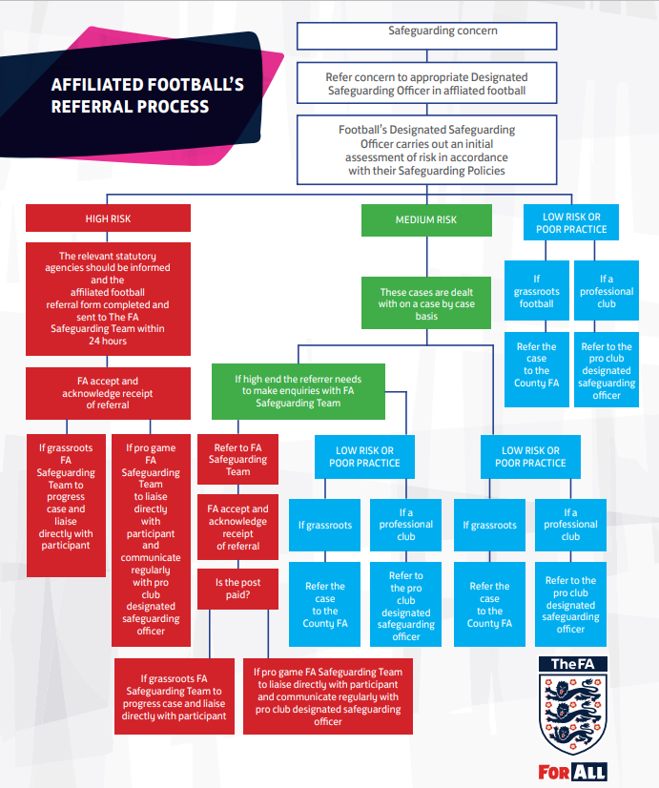

Appendix D
England Football Learning Official Complaints Procedure

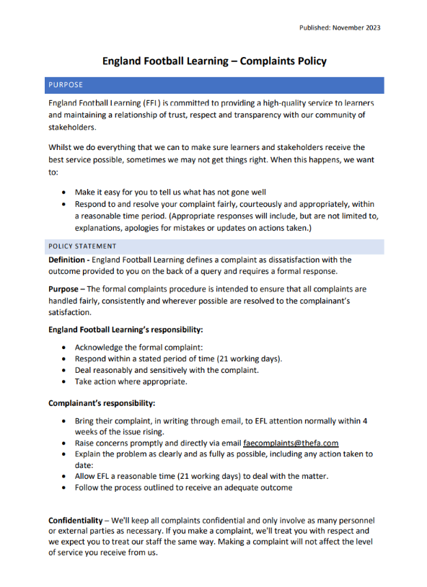
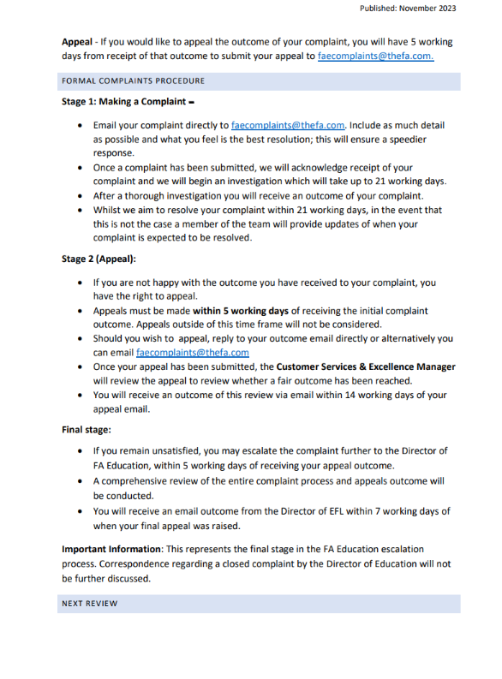

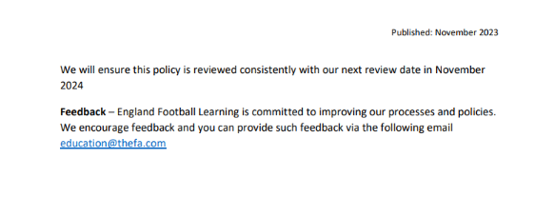
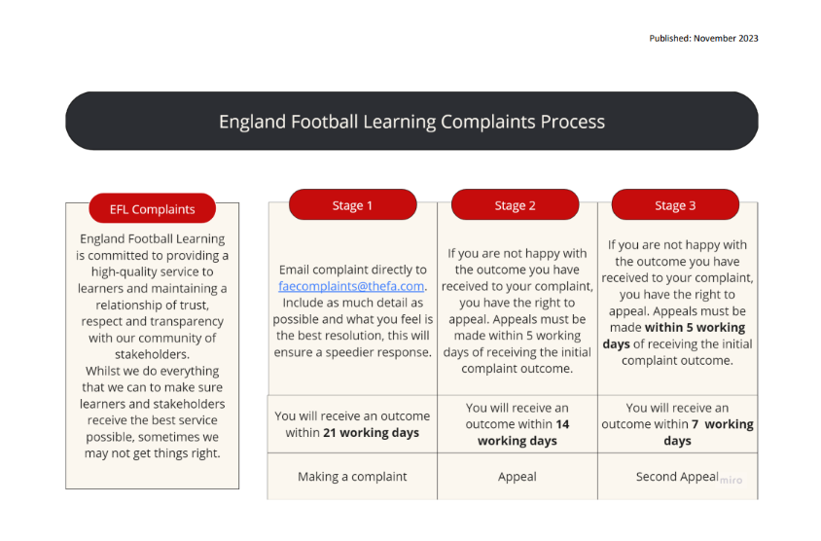

Appendix E
Managing allegations & Low level concerns

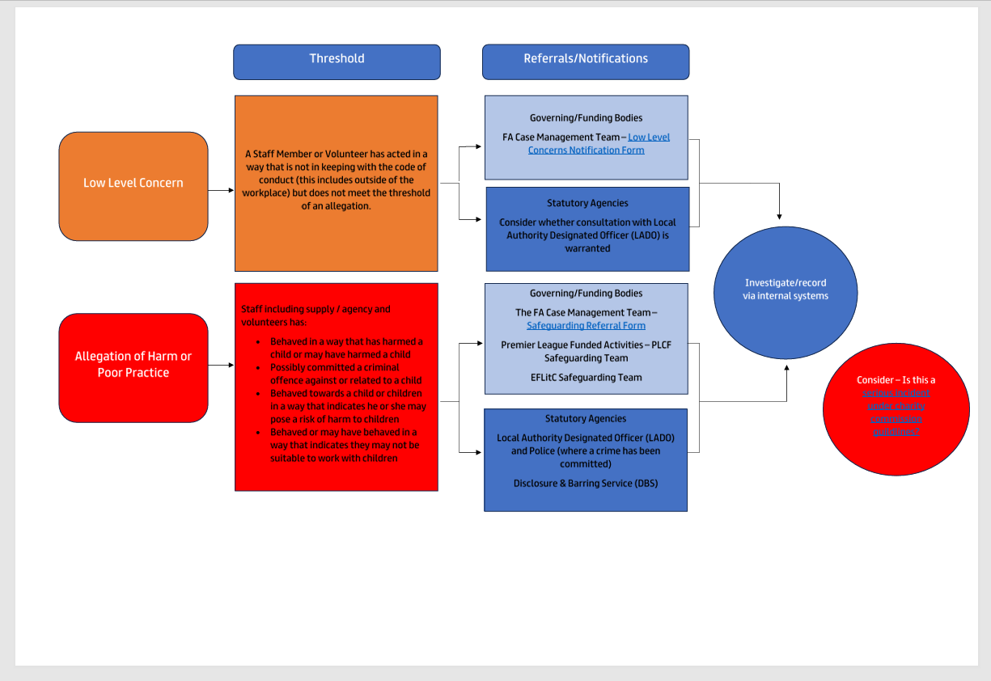

Appendix F -

Support for the ‘person in a position of trust’

Where concerns have been raised that a person in a position of trust may pose a risk to people with care and support needs, the experience is likely to be very stressful for them. Alongside the duty of care towards the adult at risk, there must be a duty of care to the employee, volunteer or student concerned.

The employer/voluntary/student body will need to provide support to minimise stress associated with the process, this may need to include where possible:
- the individual has the right to be informed of the allegation
- support for the person to understand the procedures being followed
- the right to contact their union representative at any point – should they have one
- updates on developments
- the opportunity to respond to allegations/concerns
- support to raise questions or concerns about their circumstances
- occupational health / mental health support available within the employee / volunteer’s own organisation

There may be limitations on the amount of information that can be shared at a particular time in order not to prejudice any enquiry/investigation or place any adult or child at risk. There may also be occasions where there is a need to agree changes to the Person’s working arrangements or to the support provided.

If the Person is a member of a union or professional association or network s/he should be advised that they may wish to seek support from that organisation. The Person may also wish to seek independent advice regarding employment issues. Such advice and support should be supplementary to that provided by the employer.

Consent and involvement of a person in a position of trust

Unless wholly impractical, before disclosing information to another employer, volunteer manager or student body, there is a need to consult with the person whose information is to be shared. This will give them the opportunity to respond to the concerns and make representation on the need to share the information.

If it is assessed as justified and necessary for the employer to be informed of the concerns/allegations, the person in a position of trust may wish to inform their employer/volunteer organisations/student body themselves.

If this is the case, their wish should be respected but it will still be necessary to contact the employer/volunteer organisation/student body subsequently to check that relevant information has actually been passed on. It should be made clear to that person in a position of trust that this is required.

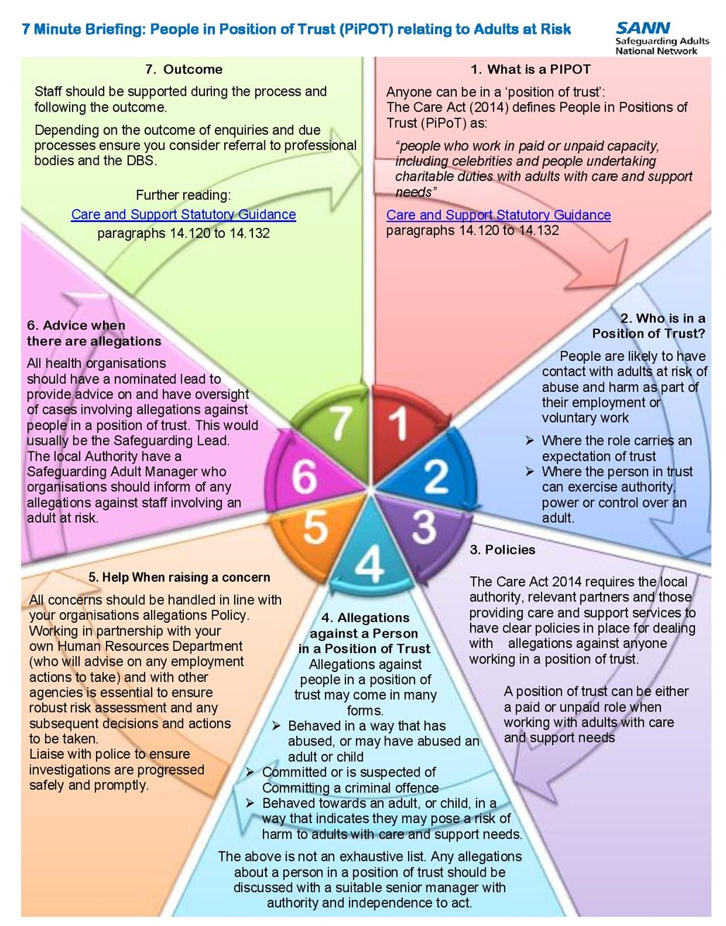

Appendix G -

Adult Safeguarding Referral

Who do I need to contact? (Trafford)

Send your referrals or queries using the Trafford Adult Social Care online portal and they will get to the team who is best placed to help with your enquiry. The TSSP AdultThreshold guidance is available here. The safeguarding adult’s threshold tool has been developed to assist practitioners in assessing the seriousness and level of risk associated with a safeguarding adults concern. The aim is to ensure that everyone understands the threshold consideration. The tool is not intended to replace professional judgement.

If you are already in contact with an adult social care team you can contact them using email:
- Request for an assessment or general queries: AdultSocialCare@trafford.gov.uk
- Safeguarding referrals and queries: AdultSafeguardinghub@trafford.gov.uk

If you think that you or an adult is in immediate danger - don’t delay call the police on 999.

Who do I need to contact? (Salford)

Complete the below referral form -
https://www.salford.gov.uk/health-and-social-care/safeguarding-adults/

If you have any problems with the online form, please call 0161 206 0604.

In an emergency call the police or ambulance 999.

Who do I need to contact? (Greater Manchester)

The Manchester Safeguarding Partnership brings together a number of agencies across the city to ensure that there is a joined up approach to adult safeguarding.

Worried about an adult?
In an emergency call 999 or call Manchester Contact Centre on 0161 234 5001 to report a concern.

