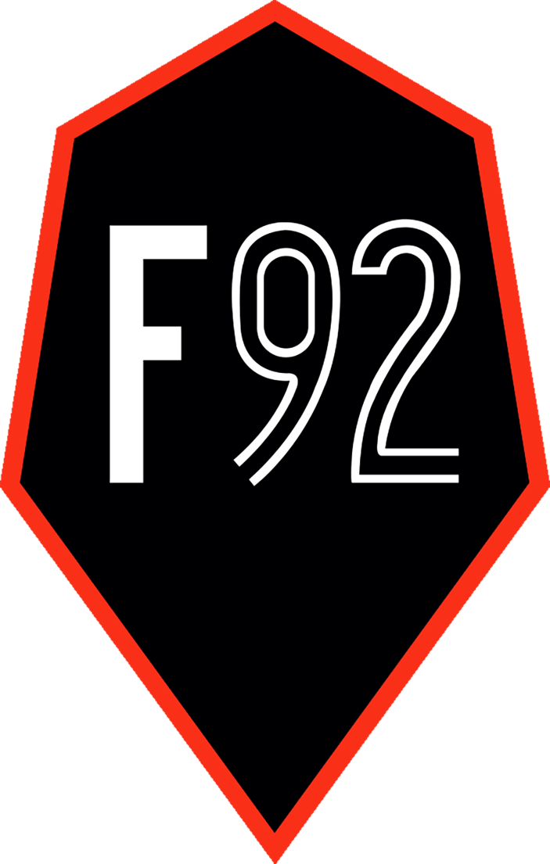

Foundation 92 Community Hub Booking Form

Please fill in the below form and return to [Marco.Wong@Foundation92.co.uk](mailto:Marco.Wong@Foundation92.co.uk)

|  |  |
| --- | --- |
| **Your Name:** |  |
| **Contact Number:** |  |
| **Email:** |  |
| **Address:** |  |

|  |  |
| --- | --- |
| **Name of Business (if applicable):** |  |
| **Are you charity?** | Yes/No |
| **Charity Registration Number (if applicable:** |  |

|  |  |
| --- | --- |
| **Reason for Hiring Facility:** |  |
| **Day & Time Slot Required*:**  e.g., Wednesday 12/06/22, 12pm-1pm |  |
| **Number of potential attendees:** |  |
| **Is this a one-time booking or would you like to set up a repeat booking?** | One-Time/Repeat Booking |

*Minimum time slot is 1 hour. Booking time after the initial 2 hours will be calculated hourly.

Under the Data Protection Regulation, your personal data is only used for purposes of Foundation 92 Community Hub’s venues booking. Foundation 92 will not sell, rent, or transfer your personal data to any person or organization. For enquiries, please email at [marco.wong@foundation92.co.uk](mailto:marco.wong@foundation92.co.uk)